# Regional Chairperson – ASJMC

Position title: Regional Chairperson – Association of St John Members Cymru

Professionally Accountable to: Deputy Chief Volunteer

Directly Accountable to: National President - ASJMC

Location: Home based

Hours: approx. 15 hours per month

Salary: This is a volunteering post

Job details:

As the Regional Chairperson for the Association of St John Members Cymru, you will proactively lead, manage and direct the Association within your region, working closely alongside the National President of the ASJMC and the Deputy Chief Volunteer.

Key duties and responsibilities:

* Proactively and professionally lead, manage, direct and support the Association within your region to achieve its aims, goals and commitments.
* Be professionally accountable and responsible for all members of the Association within your region and act as their line manager.
* Provide a single point of contact for the Association of St John Members Cymru within your region
* Liaise regularly with the National President and Deputy Chief Volunteer and disseminate all information to the members in a quick and timely fashion.
* Maintain regular contact with the National President and Members of the Association and hold meetings either virtually or in person.
* Represent the ASJMC, from time to time as requested, on relevant volunteer committees, Task and Finish Groups or Working Groups.
* Professionally lead and support the ASJMC members within your region and ensure they are being proactive in their roles.
* Ensure the expectations, policies and procedures of the Association are upheld at all times.
* Encourage and promote the recruitment and retention of Members to the Association
* Ensure the Members are proactively involved in and support functions such as Fundraising, Public Relations, Recruitment, VIP Events, Award Ceremonies and Presentations – Nationally and at County/Divisional Level.
* Encourage, organise and liaise with NHQ, Counties and Divisions in the involvement of Members of the Association in the above areas or similar functions.
* Attend and assist in recruiting, Association members to staff welfare hubs for Operational Volunteers at events, recruitment drives, fundraising or other functions.
* Maintain a comprehensive contact list of Members, Divisions, Counties and NHQ staff.
* Ensure that optimum use is made of all resources, both human and material. Encourage and ensure that Members throughout your Regions work closely together to ensure full strength in numbers.
* To liaise and assist where required with the planning of events at National, County and Divisional level. Arrange where requested, Members of the Association to assist where required.
* Maintain an overall awareness of the activities occurring or where the Association members could within your region.
* Offer advice, support, guidance and assistance to ASJMC members where required and maintain regular contact with the Deputy Chief Volunteer.
* Maintain a spreadsheet recording the number of hours provided by the ASJMC members within your region and provide this on a monthly basis to the Deputy Chief Volunteer.
* To attend meetings where required by the National President, Deputy Chief Volunteer or NHQ staff.
* To carry out any other reasonable duties as required by the National President, Deputy Chief Volunteer or NHQ staff.
* Ensure all uniform worn by all members of the Association is kept in a clean and professional standard and abides to the current Uniform Policy.
* To complete Annual Mandatory Safeguarding training
* To ensure your DBS certificate is current and in date.

Structure

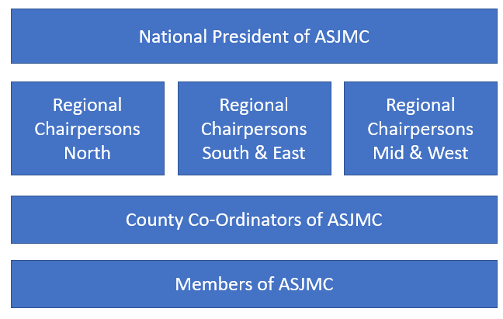

Person specification

This is a specification of the experience, skills, etc. that are required to effectively carry out the duties and responsibilities of the post (as outlined above) and forms the basis for selection.

|  |  |  |  |
| --- | --- | --- | --- |
| Requirements: | Essential: | Desirable: | Method supporting assessment: |
| Completion of Introduction to Safeguarding e-Learning | **CC:\Users\justine.thorner\AppData\Local\Microsoft\Windows\INetCache\Content.Word\Tick 2-21.png** |  | Application form |
| Hold a current BFA qualification or above | **C:\Users\justine.thorner\AppData\Local\Microsoft\Windows\INetCache\Content.Word\Tick 2-21.png** |  | Application form |
| A current (in date) DBS certificate | **C:\Users\justine.thorner\AppData\Local\Microsoft\Windows\INetCache\Content.Word\Tick 2-21.png** |  | Application form |
| Welsh Speaker |  | **C:\Users\justine.thorner\AppData\Local\Microsoft\Windows\INetCache\Content.Word\Tick 2-21.png** | Application form |
| Event Management experience |  | **C:\Users\justine.thorner\AppData\Local\Microsoft\Windows\INetCache\Content.Word\Tick 2-21.png** | Application form |
| A minimum of 5 years continued service | **C:\Users\justine.thorner\AppData\Local\Microsoft\Windows\INetCache\Content.Word\Tick 2-21.png** |  | Application form |
|  |  |  |  |
| Skills, knowledge and abilities | | | |
| Proven experience of effective and appropriate decision making | **C:\Users\justine.thorner\AppData\Local\Microsoft\Windows\INetCache\Content.Word\Tick 2-21.png** |  | Interview |
| Experience of Managing people | **C:\Users\justine.thorner\AppData\Local\Microsoft\Windows\INetCache\Content.Word\Tick 2-21.png** |  | Interview |
| Experience of communicating with volunteers and staff | **C:\Users\justine.thorner\AppData\Local\Microsoft\Windows\INetCache\Content.Word\Tick 2-21.png** |  | Interview |
| Experience in Fundraising, PR and Recruitment | **C:\Users\justine.thorner\AppData\Local\Microsoft\Windows\INetCache\Content.Word\Tick 2-21.png** |  | Interview |
| Excellent verbal and written communication and presentation skills | **C:\Users\justine.thorner\AppData\Local\Microsoft\Windows\INetCache\Content.Word\Tick 2-21.png** |  | Interview |
| Computer literacy | **C:\Users\justine.thorner\AppData\Local\Microsoft\Windows\INetCache\Content.Word\Tick 2-21.png** |  | Interview |
| Ability to work on own initiative and part of a team | **C:\Users\justine.thorner\AppData\Local\Microsoft\Windows\INetCache\Content.Word\Tick 2-21.png** |  | Interview |
| Knowledge of Risk Assessments |  | **C:\Users\justine.thorner\AppData\Local\Microsoft\Windows\INetCache\Content.Word\Tick 2-21.png** | Interview |
| Good understanding of volunteer needs, ambitions and expectations | **C:\Users\justine.thorner\AppData\Local\Microsoft\Windows\INetCache\Content.Word\Tick 2-21.png** |  | Interview |
| Knowledge of all regulations and procedures that apply to SJAC |  | **C:\Users\justine.thorner\AppData\Local\Microsoft\Windows\INetCache\Content.Word\Tick 2-21.png** | Interview |
| Flexible to travel pan Wales as required | **C:\Users\justine.thorner\AppData\Local\Microsoft\Windows\INetCache\Content.Word\Tick 2-21.png** |  | Interview |
| Willingness to commit the time to the role | **C:\Users\justine.thorner\AppData\Local\Microsoft\Windows\INetCache\Content.Word\Tick 2-21.png** |  | Interview |
| Organised and efficient | **C:\Users\justine.thorner\AppData\Local\Microsoft\Windows\INetCache\Content.Word\Tick 2-21.png** |  | Interview |
| Approachable, supportive and maintains personal integrity | **C:\Users\justine.thorner\AppData\Local\Microsoft\Windows\INetCache\Content.Word\Tick 2-21.png** |  | Interview |